**Experiment No 3**

**Shashwat Tripathi  
D15A 64  
Batch C**

**Aim-** To understand the Kubernetes Cluster Architecture, install and Spin Up a Kubernetes Cluster on Linux Machines/Cloud Platforms.

**1) Launch 2 EC2 instance and select Ubuntu in AMI**

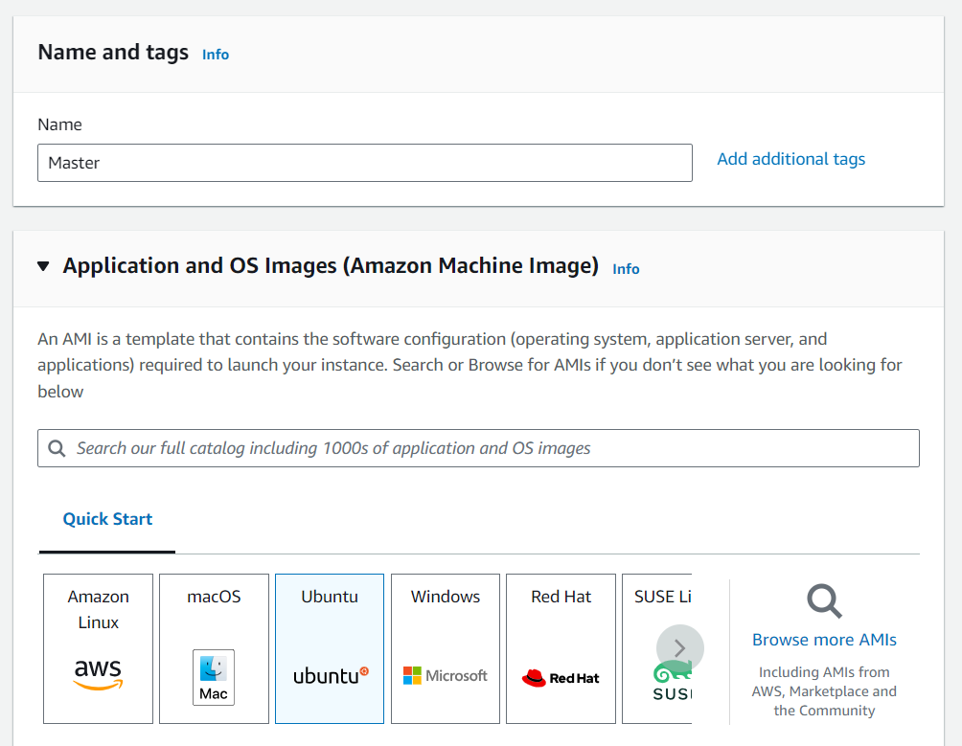

**2) Create new key pair**

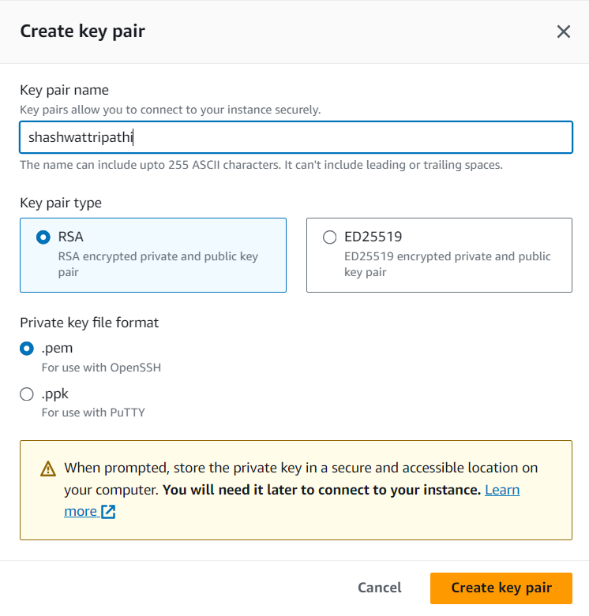

**3) In Security group select all checkbox and launch instance**

**4) Go to security group and edit inbound rules of both instance**

**5) Delete all the rules and add new rule with All traffic and Anywhere-IPv4**

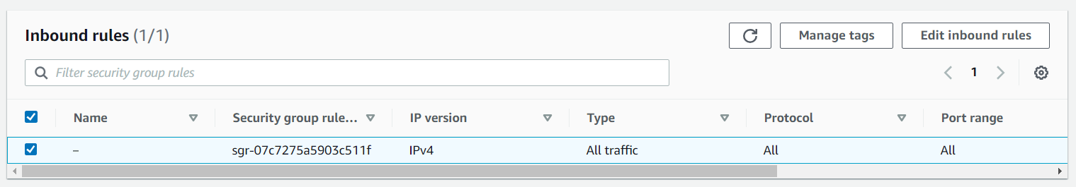

6) Now in running instances click on master instance and click on connect

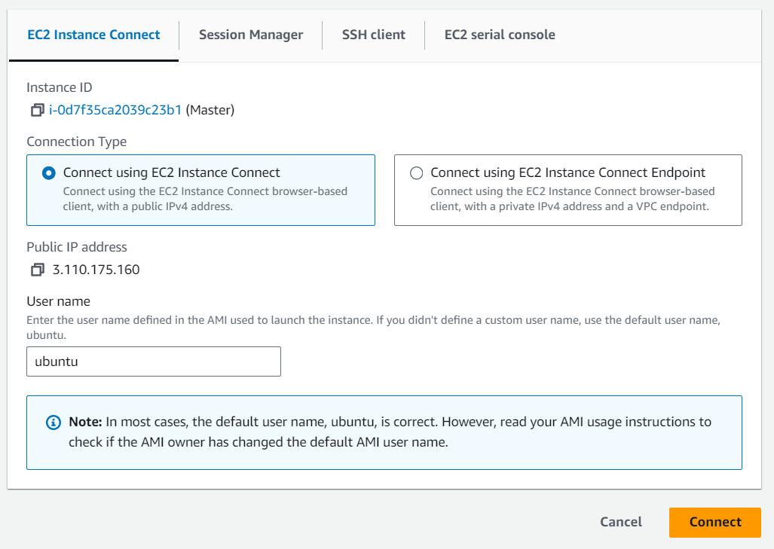

**8) Similarly connect the worker**

**9) Set hostname to master and worker respectively**



 

**10) Use command sudo apt-get update on both master and worker CLI**

sudo apt-get updateon both

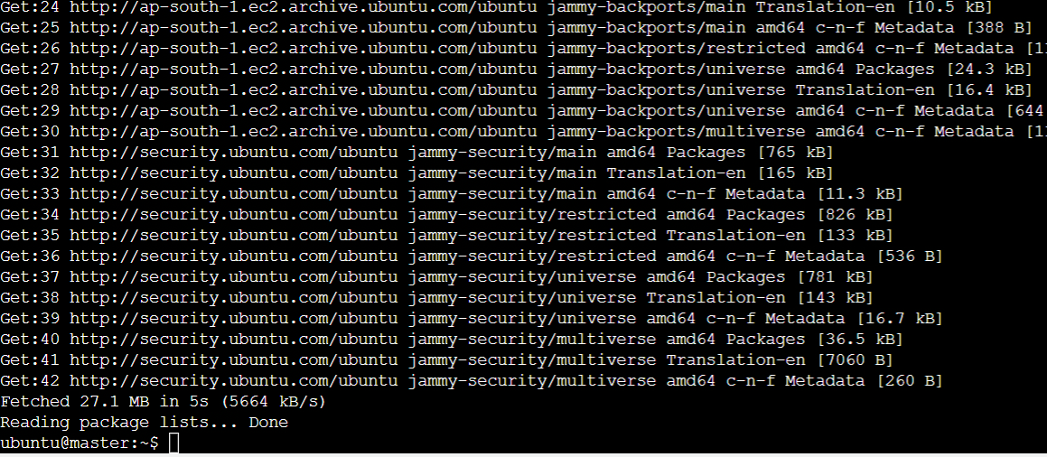

**11) Installing Docker on both CLI**

sudo apt-get install docker.io on both

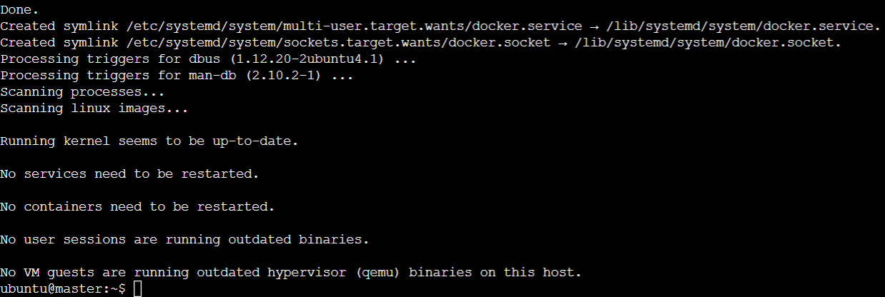

**12) Enable Docker on both CLI and check its status**

sudo systemctl enable docker  
sudo systermctl status dockeron both

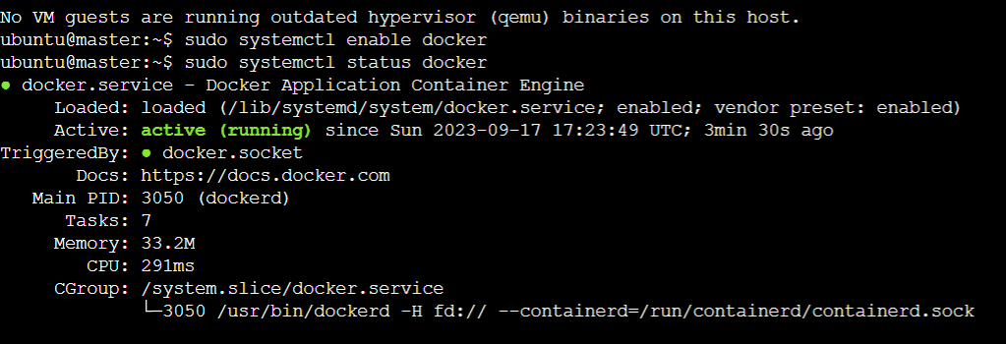

**DOCKER INSTALLED SUCCESSFULLY**

**13) Now for Installing Kubernetes (On both CLI)**

sudo apt-get update

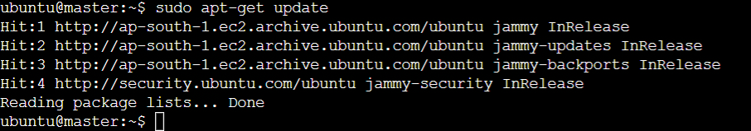

sudo apt-get install -y apt-transport-https ca-certificates curl

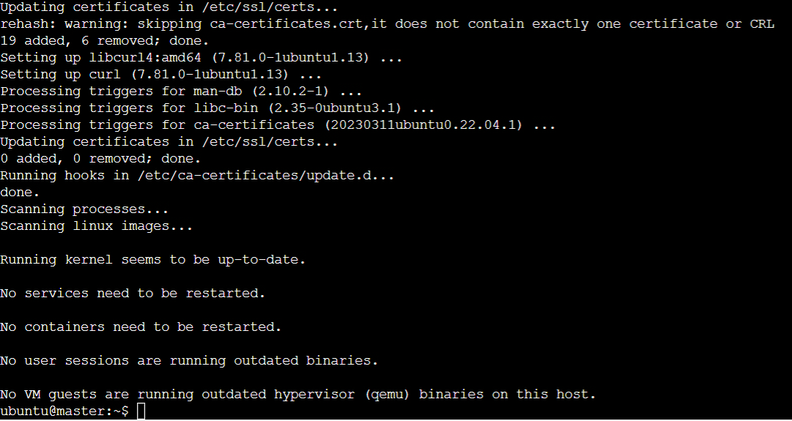

**14) Download Google cloud public signing key**

sudo curl -fsSLo /usr/share/keyrings/kubernetes-archive-keyring.gpg <https://dl.k8s.io/apt/doc/apt-key.gpg>



**15) Adding kubernetes apt repository**

echo "deb [signed-by=/usr/share/keyrings/kubernetes-archive-keyring.gpg] https://apt.kubernetes.io/ kubernetes-xenial main" | sudo tee /etc/apt/sources.list.d/kubernetes.list



**16) Run this 3 commands**

sudo apt-get update

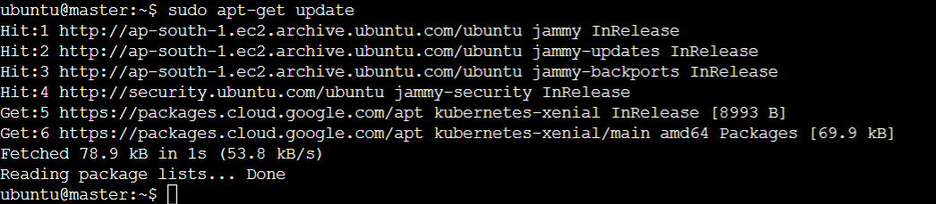

sudo apt-get install -y kubelet kubeadm kubectl

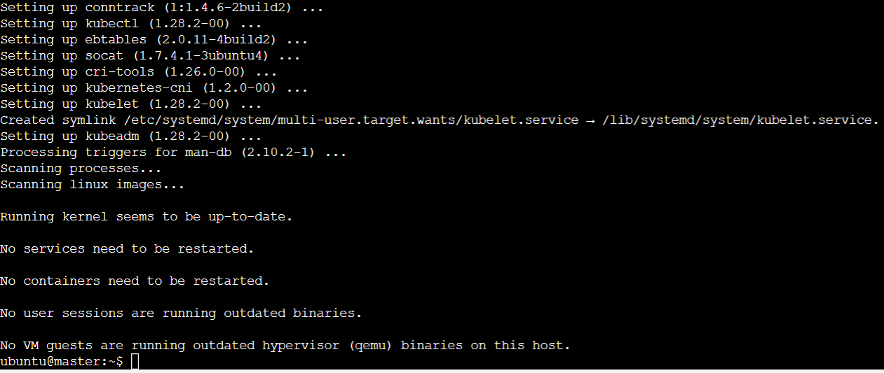

sudo apt-mark hold kubelet kubeadm kubectl

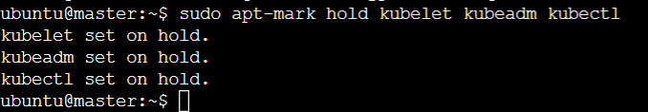

**KUBERNETES INSTALLED SUCCESSFULLY**

**17) Kubernetes Deployment**

sudo swapoff -a



**18) Initialize kubernetes on Master**

sudo touch "/etc/docker/daemon.json"

sudo nano "/etc/docker/daemon.json" Run this command and copy paste this

{

"exec-opts": ["native.cgroupdriver=systemd"]

}

Then press ctrl + O and enter then ctrl + X

sudo cat "/etc/docker/daemon.json"

sudo systemctl daemon-reload

sudo systemctl restart docker

sudo systemctl restart kubelet

sudo kubeadm reset



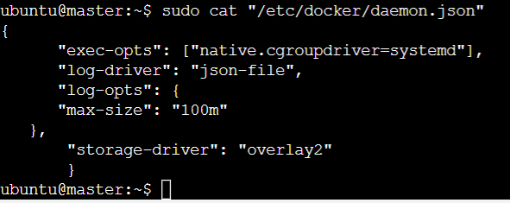

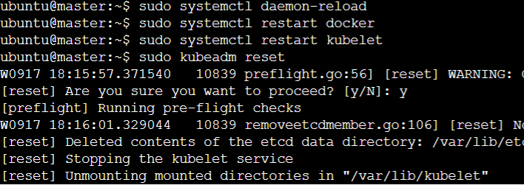

$ sudo kubeadm init --pod-network-cidr=10.244.0.0/16 --ignore-preflight-errors=all

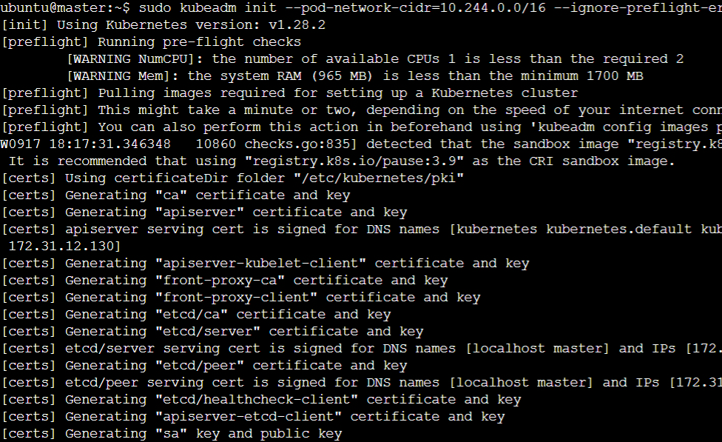

kubeadm join 172.31.12.130:6443 --token 67nba2.98zekjx1ogwtrr29 --discovery-token-ca-cert-hash sha256:5d3403f5221016f77cbed1757a266467af45dc41b765ebe535f15ee058baf883

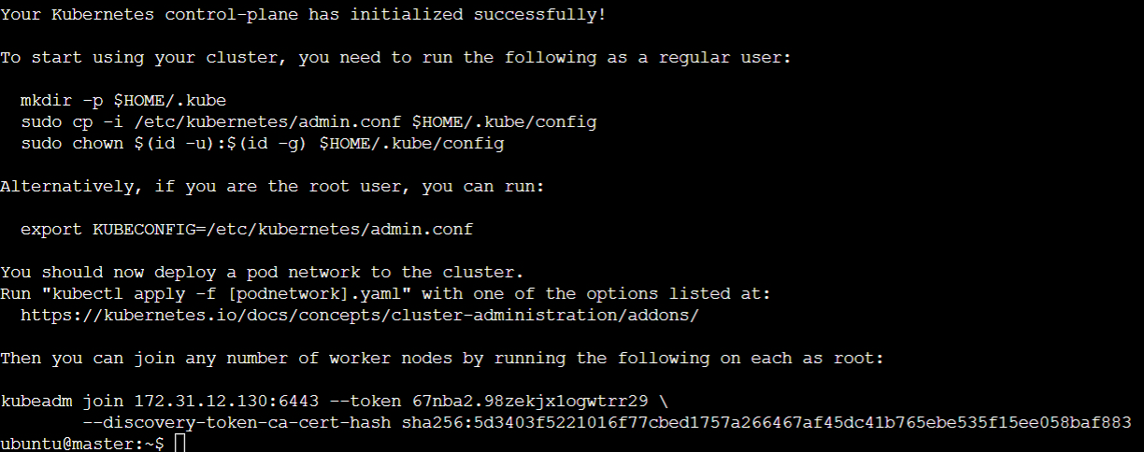

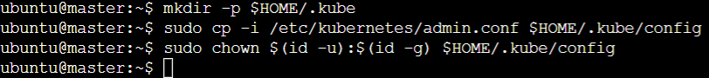

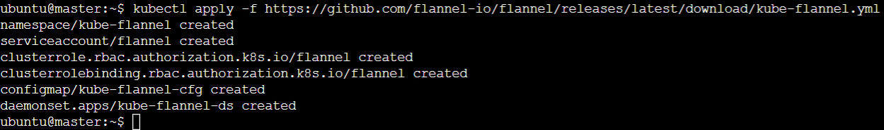

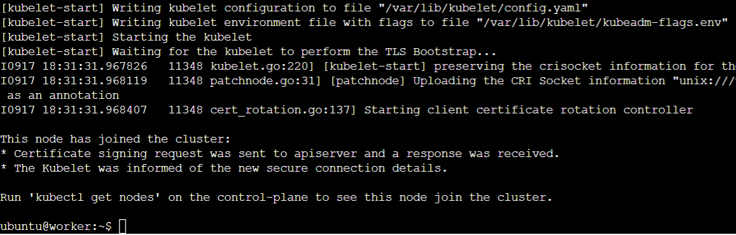



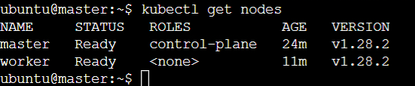

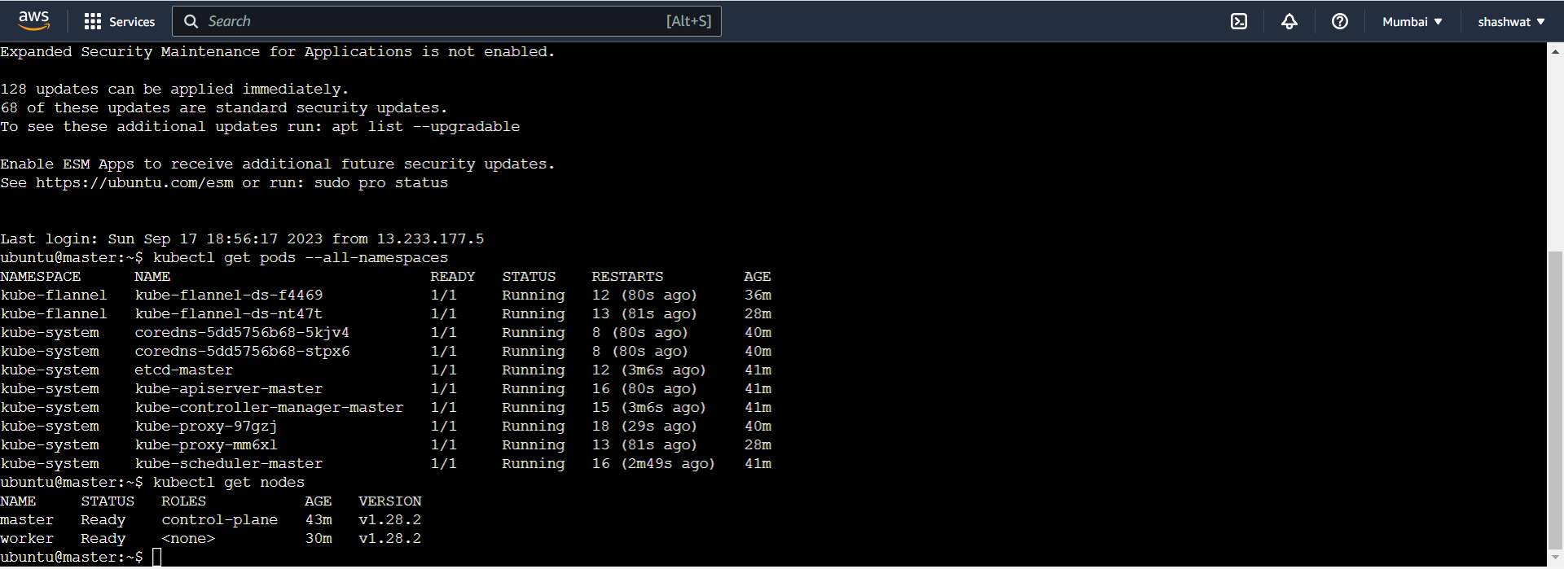

**Conclusion:**

Thus we have understood the Kubernetes Cluster Architecture, installed and spun a Kubernetes Cluster on AWS Cloud Platform.

**Error:**The status of all namespaces was not showing running in the first try, but when I rebooted the master and worker instances it was successful.